**Architectural Design of Payment Gateway for SundarBan E-commerce**

In our class, we have designed the following architecture for sundarban e-commerce payment method.

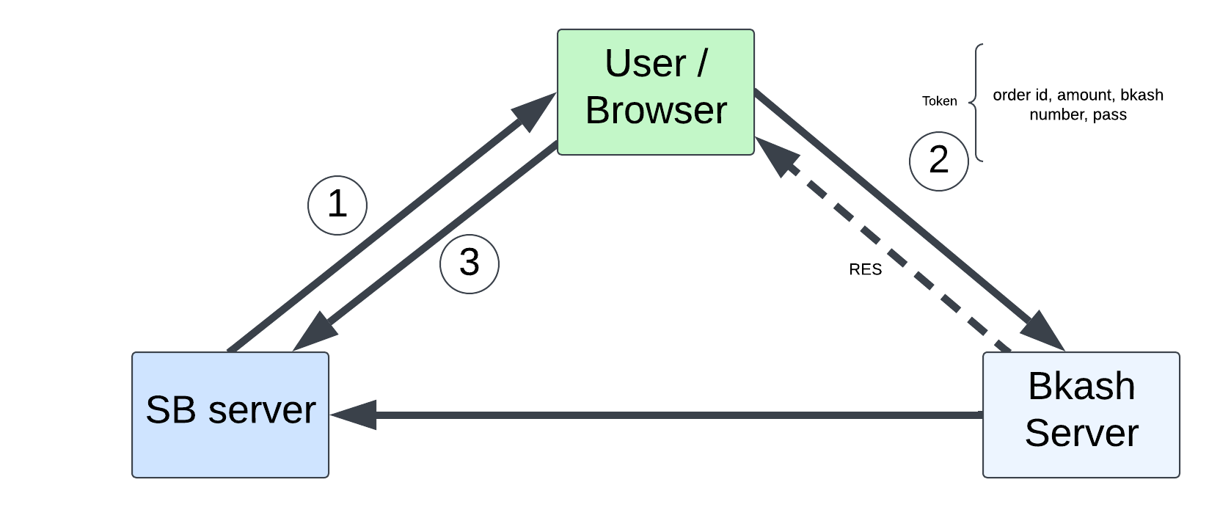

Figure-01: Bkash payment gateway for SunadarBan (SB) e-commerce.

**Workflow/Information Flow:**

1. **SB Server (SundarBan Server):** Manages the e-commerce platform (orders, inventory etc.) and communicate with Bkash server.
2. **User/Browser:** User place an order and select Bkash as a payment method. SB redirect user to the payment method page as a response (1). User give appropriate information and pass these as a token to the Bkash server (2).
3. **Bkash Server:** Process the payment and send a response RES for payment status (successful, failure, …). Then user send this status to the SB server (3). At this time, Bkash server send the payment history to the SB server (Bkash server🡪SB server). Then SB server validate the payment and process the order accordingly.

**Issues with this architecture:**

1. If either the SB server or Bkash server goes down, the payment process halts entirely.
2. If the user doesn’t return to the website after completing the payment, how the SB server know about the transaction’s status?
3. Scalability: As the user interacts directly with the Bkash using token, scaling to handle thousands of concurrent transactions might introduce latency or token management issues.

**Improved Architecture:**

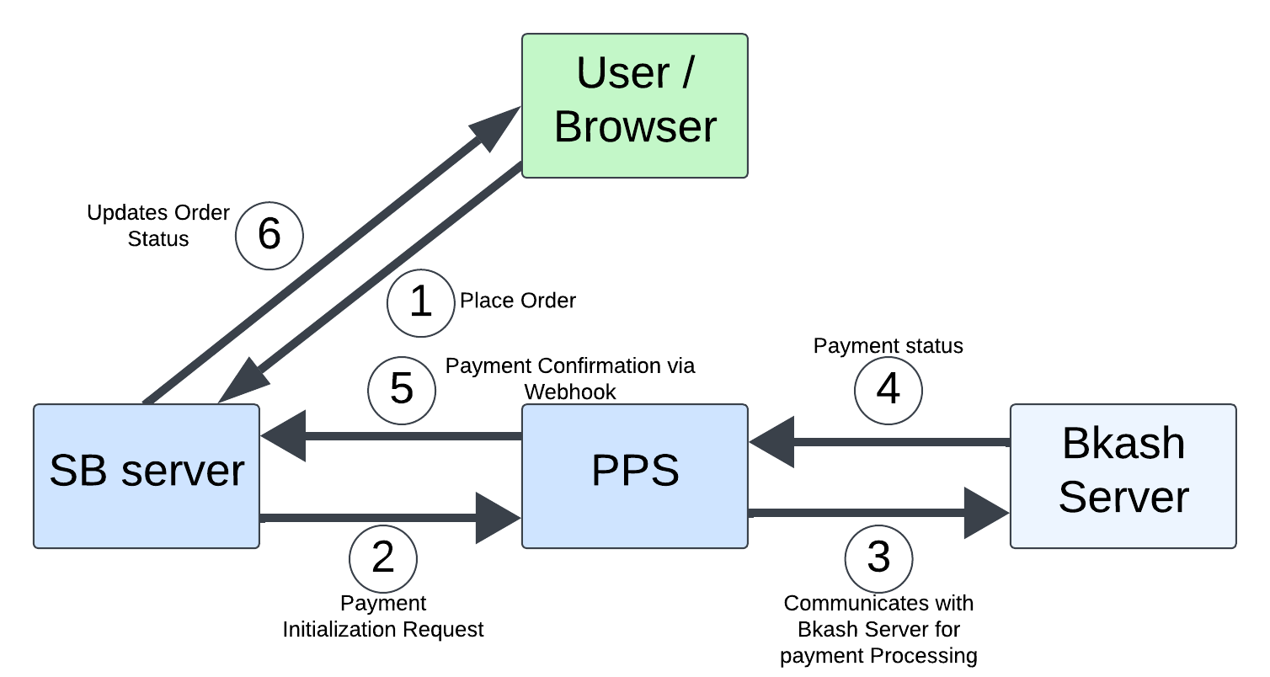

Figure-02: Bkash payment gateway for SunadarBan (SB) e-commerce.

I was designed to fixes the above issue of Figure-01 architecture. But after designing, I have noticed why user share his bkash number or password with third part (SB server), after selecting the payment method he should redirect to the Bkash payment gateway directly.

Besides I think the PPS (Payment Proxy Service) adds complexity and additional point of failure. So, I have tried to redesign the architecture which is given below:

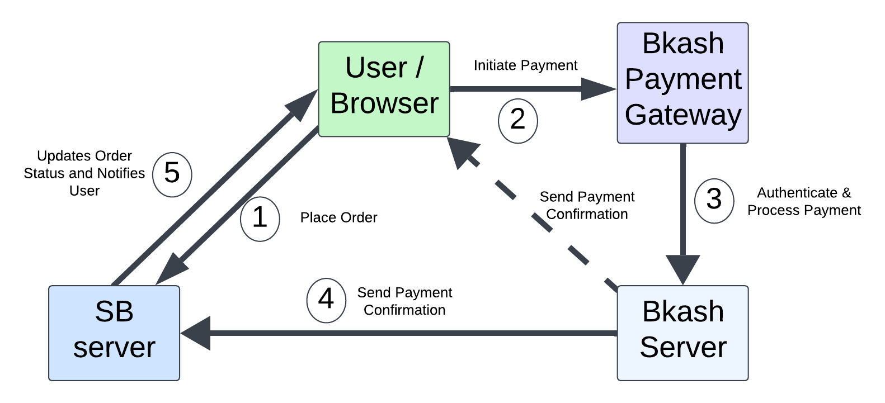Figure-03: Bkash payment gateway for SunadarBan (SB) e-commerce.

**Workflow:**

1. **User/Browser:** The user places an order on the SundarBan (SB) e-commerce website.During checkout, the user selects Bkash as the payment method.The SB Server redirects the user to the Bkash Payment Gateway page or integrates Bkash's SDK directly into the user interface.
2. **Bkash Payment Gateway (SDK):** The SDK handles user interaction for payment credentials (mobile number, PIN, OTP).It securely transmits the payment details directly to the Bkash Server.
3. **Bkash Server:** The Bkash Server authenticates the payment details and processes the transaction.Once the payment is processed, the Bkash Server sends a payment confirmation response (success, failure, or pending) back to the user. The Bkash server also send the payment confirmation status to the SB Server.
4. **SB Server:** The SB Server validates the payment status by cross-checking it with the information

provided by the Bkash Server.It updates the order status in its database (paid, pending, failed).The SB Server sends a confirmation to the user (via email, SMS, or in-app notification) about the payment and order status.